**Department of Computer Science & Engineering, SDMCET, Dharwad-2**



**AOOP Assignment 2 Submission Report**

**[Submitted as part of CTA Assignment No-1]**

**Course: Advanced Object-Oriented Programming Course**

**Code: 18UCSE508**

**Semester: V**

**Division:A**

**Submitted by: Aachan B kulkarni**

**USN:2SD20CS002**

1. **Problem Definition:**

**Write a Java program to build the GUI application using JavaFX for the following requirements:**

**a) Read user name and password using appropriate JavaFX controls.**

**b) Validate the input. If user name and password are matched with the assumed values, then**

**display the welcome scene with proper text.**

**c) If user name and password don’t match, then raise appropriate exception.**

1. **Problem Definition:**

**Write a Java program to build the GUI application using JavaFX for the following requirements:**

**a) Create a Menu control to display the menu items: File, Edit & Help.**

**b) Create sub menus in the order: File → New, Open & Save. Edit → Cut, Copy & Paste.**

**Help → Help Centre, About Us**

**The program must use Mnemonics and Accelerators (wherever appropriate) to Menu Items.**

1. **Problem Definition:**

**Write a Java program to build the GUI application using JavaFX for the following requirements:**

**a) Create Context menu involving the menu items in the order: New & View.**

**b) Create sub menus for the above main context menu: New → File, Folder & Image.**

**View → Large, Medium & Small.**

**The context menu must be displayed on right-click of the mouse button.**

1. **Problem Definition:**

**Write a JavaFX program that produces the following output when executed and displays Dialog Box**

**(as shown in Figure.2) on click of Register button (as shown in Figure.1):**

1. **Problem Definition:**

**Write a Java program to build the GUI application using JavaFX for the following requirements:**

**a) Read user name and password using appropriate JavaFX controls.**

**b) Validate the input. If user name and password are matched with the assumed values, then**

**display the welcome scene with proper text.**

**c) If user name and password don’t match, then raise appropriate exception.**

**CODE PART:-**

**package** application;

//Demonstrate a text field.

**import** javafx.application.*;

**import** javafx.scene.*;

**import** javafx.stage.*;

**import** javafx.scene.layout.*;

**import** javafx.scene.control.*;

**import** javafx.event.*;

**import** javafx.geometry.*;

**class** InvalidException **extends** Exception {

}

**public** **class** Questionnum1 **extends** Application {

TextField tf,tff;

Label response;

Label response1;

**public** **static** **void** main(String[] args) {

// Start the JavaFX application by calling launch().

*launch*(args);

}

// Override the start() method.

**public** **void** start(Stage myStage) {

// Give the stage a title.

myStage.setTitle("Read Uname and pasword");

// Use a FlowPane for the root node. In this case,

// vertical and horizontal gaps of 10.

FlowPane rootNode = **new** FlowPane(50, 50);

// Center the controls in the scene.

rootNode.setAlignment(Pos.***CENTER***);

// Create a scene.

Scene myScene = **new** Scene(rootNode, 400, 600);

// Set the scene on the stage.

myStage.setScene(myScene);

// Create a label that will report the contents of the

// text field.

response = **new** Label("Verify Name: ");

//response1= new Label("Verify password: ");

// Create a button that gets the text.

Button btnGetUserName = **new** Button("Login If Valid");

Separator separator = **new** Separator();

separator.setPrefWidth(180);

response1= **new** Label("Verify password: ");

// Button btnGetUserName = new Button("Get Password");

Separator separator1 = **new** Separator();

separator1.setPrefWidth(180);

// Create a text field.

tf = **new** TextField();

tff= **new** TextField();

// Set the prompt.

tf.setPromptText("Enter UserName");

tff.setPromptText("Enter password");

// Set preferred column count.

tf.setPrefColumnCount(30);

tff.setPrefColumnCount(30);

// Handle action events for the text field. Action

// events are generated when ENTER is pressed while

// the text field has input focus. In this case, the

// text in the field is obtained and displayed.

tf.setOnAction(**new** EventHandler<ActionEvent>() {

**public** **void** handle(ActionEvent ae) {

response.setText("UserName: " + tf.getText());

}

});

// Separator separator = new Separator();

// separator.setPrefWidth(180);

tff.setOnAction(**new** EventHandler<ActionEvent>() {

**public** **void** handle(ActionEvent ae) {

response1.setText("Password: " + tff.getText());

}

});

//Separator separator1 = new Separator();

//separator1.setPrefWidth(180);

// Get text from the text field when the button is pressed

// and display it.

btnGetUserName.setOnAction(**new** EventHandler<ActionEvent>() {

**public** **void** handle(ActionEvent ae) {

**try** {

**if**(tf.getText().equals(**null**) || tff.getText().equals(**null**)) {

response.setText("empty");

}

**else** **if**(tf.getText().equals("aachan") && tff.getText().equals("002"))

{

response.setText("User Name: " + tf.getText());

response1.setText("password: " + tff.getText());

myStage.setTitle("LOGIN SCREEN");

FlowPane rootNode = **new** FlowPane(50, 50);

// Center the controls in the scene.

rootNode.setAlignment(Pos.***CENTER***);

// Create a scene.

Scene myScene = **new** Scene(rootNode, 400, 600);

// Set the scene on the stage.

myStage.setScene(myScene);

}

**else**

{

response.setText("U entered a invalid name");

response1.setText("U entered inavalid password");

**throw** **new** InvalidException();

}

} **catch**(InvalidException i) {

}

}

});

// Separator separator = new Separator();

separator.setPrefWidth(180);

/*

btnGet.setOnAction(new EventHandler<ActionEvent>() {

public void handle(ActionEvent ae) {

}

});*/

// Use a separator to better organize the layout.

// Separator separator1 = new Separator();

separator1.setPrefWidth(180);

// Add controls to the scene graph.

rootNode.getChildren().addAll(tf,tff, btnGetUserName, separator,separator1, response,response1);

// Show the stage and its scene.

myStage.show();

}

}

**OUTPUT:-**

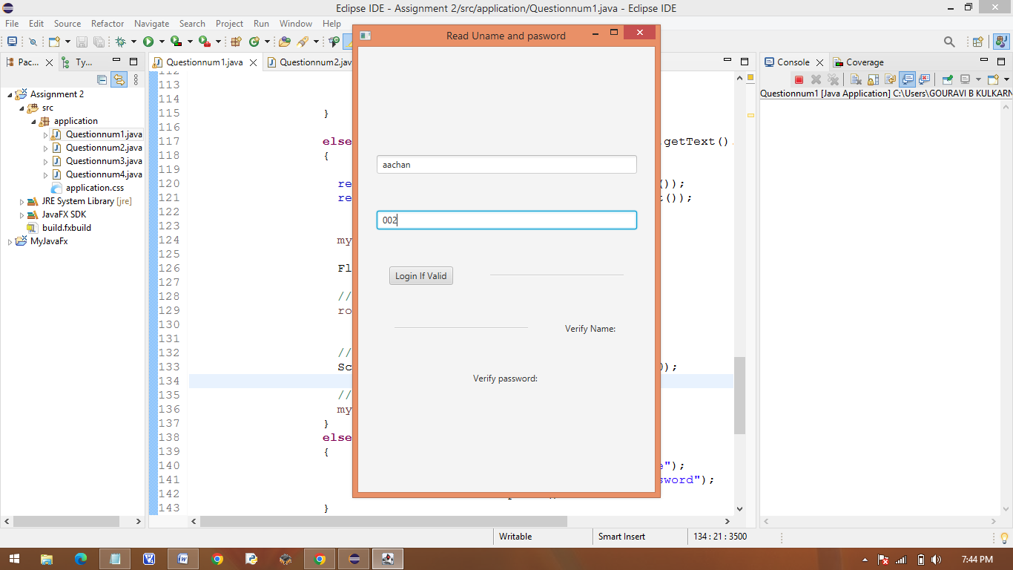

**2.Write a Java program to build the GUI application using JavaFX for the following requirements:**

**a) Create a Menu control to display the menu items: File, Edit & Help.**

**b) Create sub menus in the order: File → New, Open & Save. Edit → Cut, Copy & Paste.**

**Help → Help Centre, About Us**

**The program must use Mnemonics and Accelerators (wherever appropriate) to Menu Items.**

**CODE PART:-**

**package** application;

/*

public class AS22 {

}*/

//package application;

/*

public class MenuMnemonicsAcceleratorDemo {

}*/

//package application;

//Demonstrate Menus

**import** javafx.application.*;

**import** javafx.scene.*;

**import** javafx.stage.*;

**import** javafx.scene.layout.*;

**import** javafx.scene.control.*;

**import** javafx.scene.input.*;

**import** javafx.event.*;

**public** **class** Questionnum2 **extends** Application {

Label response;

**public** **static** **void** main(String[] args) {

// Start the JavaFX application by calling launch().

*launch*(args);

}

// Override the start() method.

**public** **void** start(Stage myStage) {

// Give the stage a title.

myStage.setTitle("Menu control");

// Use a BorderPane for the root node.

BorderPane rootNode = **new** BorderPane();

// Create a scene.

Scene myScene = **new** Scene(rootNode, 300, 300);

// Set the scene on the stage.

myStage.setScene(myScene);

// Create a label that will report the selection.

response = **new** Label("Menu Demo");

// Create the menu bar.

MenuBar mb = **new** MenuBar();

// Create the File menu.

Menu fileMenu = **new** Menu("_File"); // now defines a mnemonic

MenuItem New = **new** MenuItem("New");

MenuItem open = **new** MenuItem("Open");

MenuItem save = **new** MenuItem("Save");

fileMenu.getItems().addAll(New,open,save, **new** SeparatorMenuItem());

// Turn on mnemonic

fileMenu.setMnemonicParsing(**true**);

// Add keyboard accelerators for the File menu.

New.setAccelerator(KeyCombination.*keyCombination*("ctrl+N"));

open.setAccelerator(KeyCombination.*keyCombination*("ctrl+O"));

save.setAccelerator(KeyCombination.*keyCombination*("ctrl+S"));

// Add File menu to the menu bar.

mb.getMenus().add(fileMenu);

// Create the Options menu.

Menu editMenu = **new** Menu("Edit");

// Create the Colors sub-menu.

MenuItem cutMenu = **new** MenuItem("Cut");

editMenu.getItems().add(cutMenu);

// Create the Colors sub-menu.

MenuItem copyMenu = **new** MenuItem("Copy");

editMenu.getItems().add(copyMenu);

// Create the Priority sub-menu.

MenuItem pasteMenu = **new** MenuItem("Paste");

editMenu.getItems().add(pasteMenu);

// Add a separator.

// editMenu.getItems().add(new SeparatorMenuItem());

// Add Options menu to the menu bar.

mb.getMenus().add(editMenu);

// Create the Help menu.

Menu helpMenu = **new** Menu("Help");

MenuItem aboutus = **new** MenuItem("AboutUs");

helpMenu.getItems().add(aboutus);

MenuItem helpcenter= **new** MenuItem("Help Center");

helpMenu.getItems().add(helpcenter);

// Add Help menu to the menu bar.

mb.getMenus().add(helpMenu);

// Create one event handler that will handle menu action events.

EventHandler<ActionEvent> MEHandler = **new** EventHandler<ActionEvent>() {

**public** **void** handle(ActionEvent ae) {

String name = ((MenuItem) ae.getTarget()).getText();

// If Exit is chosen, the program is terminated.

**if** (name.equals("Exit"))

Platform.*exit*();

response.setText(name + " selected");

}

};

// Set action event handlers for the menu items.

New.setOnAction(MEHandler);

open.setOnAction(MEHandler);

save.setOnAction(MEHandler);

cutMenu.setOnAction(MEHandler);

copyMenu.setOnAction(MEHandler);

pasteMenu.setOnAction(MEHandler);

helpMenu.setOnAction(MEHandler);

aboutus.setOnAction(MEHandler);

// Add the menu bar to the top of the border pane and

// the response label to the center position.

rootNode.setTop(mb);

rootNode.setCenter(response);

// Show the stage and its scene.

myStage.show();

}

}

**OUTPUT:-**

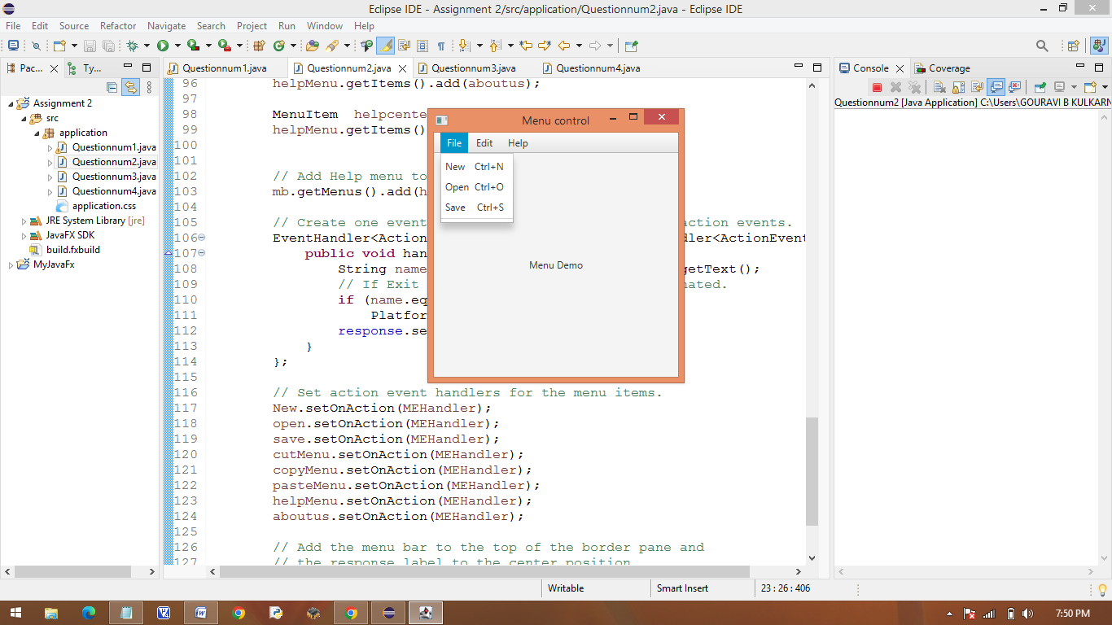

1. **Problem Definition:**

**Write a Java program to build the GUI application using JavaFX for the following requirements:**

**a) Create Context menu involving the menu items in the order: New & View.**

**b) Create sub menus for the above main context menu: New → File, Folder & Image.**

**View → Large, Medium & Small.**

**The context menu must be displayed on right-click of the mouse button.**

**CODE PART:-**

**package** application;

/*

public class AS23 {

}

*/

//package application;

/*

public class ContextMenuDemo {

}*/

//package application;

//Demonstrate Menus

**import** javafx.application.*;

**import** javafx.scene.*;

**import** javafx.stage.*;

**import** javafx.scene.layout.*;

**import** javafx.scene.control.*;

**import** javafx.event.*;

**import** javafx.geometry.Pos;

**public** **class** Questionnum3 **extends** Application {

Label response;

**public** **static** **void** main(String[] args) {

// Start the JavaFX application by calling launch().

*launch*(args);

}

// Override the start() method.

**public** **void** start(Stage myStage) {

// Give the stage a title.

myStage.setTitle("Demonstrate Menus");

// Use a BorderPane for the root node.

BorderPane rootNode = **new** BorderPane();

// Create a scene.

Scene myScene = **new** Scene(rootNode, 300, 300);

// Set the scene on the stage.

myStage.setScene(myScene);

// Create a label that will report the selection.

response = **new** Label("Menu Demo");

// Create the menu bar.

MenuBar mb = **new** MenuBar();

// Create the New menu.

Menu NewMenu = **new** Menu("New");

//create the view submenu

MenuItem file = **new** MenuItem("File");

MenuItem folder = **new** MenuItem("Folder");

MenuItem image = **new** MenuItem("image");

NewMenu.getItems().addAll(file,folder,image, **new** SeparatorMenuItem());

// Add New menu to the menu bar.

mb.getMenus().add(NewMenu);

// Create the view menu.

Menu viewMenu = **new** Menu("View");

// Create the view sub-menu.

MenuItem large = **new** MenuItem("Large");

MenuItem medium = **new** MenuItem("Medium");

MenuItem small = **new** MenuItem("Small");

viewMenu.getItems().addAll(large,medium,small,**new** SeparatorMenuItem());

// Add a separator.

// viewMenu.getItems().add(new SeparatorMenuItem());

// Add view menu to the menu bar.

mb.getMenus().add(viewMenu);

// Create the context menu items

MenuItem cut = **new** MenuItem("Cut");

MenuItem copy = **new** MenuItem("Copy");

MenuItem paste = **new** MenuItem("Paste");

// Create a context (i.e., popup) menu that shows edit options.

**final** ContextMenu editMenu = **new** ContextMenu(cut, copy, paste);

// Create one event handler that will handle menu action events.

EventHandler<ActionEvent> MEHandler = **new** EventHandler<ActionEvent>() {

**public** **void** handle(ActionEvent ae) {

String name = ((MenuItem) ae.getTarget()).getText();

// If Exit is chosen, the program is terminated.

**if** (name.equals("Exit"))

Platform.*exit*();

response.setText(name + " selected");

}

};

// Set action event handlers for the menu items.

file.setOnAction(MEHandler);

folder.setOnAction(MEHandler);

image.setOnAction(MEHandler);

large.setOnAction(MEHandler);

medium.setOnAction(MEHandler);

small.setOnAction(MEHandler);

cut.setOnAction(MEHandler);

copy.setOnAction(MEHandler);

paste.setOnAction(MEHandler);

// Create a text field and set its column width to 20.

TextField tf = **new** TextField();

tf.setPrefColumnCount(20);

// Add the context menu to the textfield.

tf.setContextMenu(editMenu);

// Add the menu bar to the top of the border pane and

// the response label to the center position.

rootNode.setTop(mb);

// Create a flow pane that will hold both the response

// label and the text field.

FlowPane fpRoot = **new** FlowPane(10, 10);

// Center the controls in the scene.

fpRoot.setAlignment(Pos.***CENTER***);

// Add both the label and the text field to the flow pane.

fpRoot.getChildren().addAll(response, tf);

// Add the flow pane to the center of the border layout.

rootNode.setCenter(fpRoot);

// Show the stage and its scene.

myStage.show();

}

}

**OUTPUT:-**

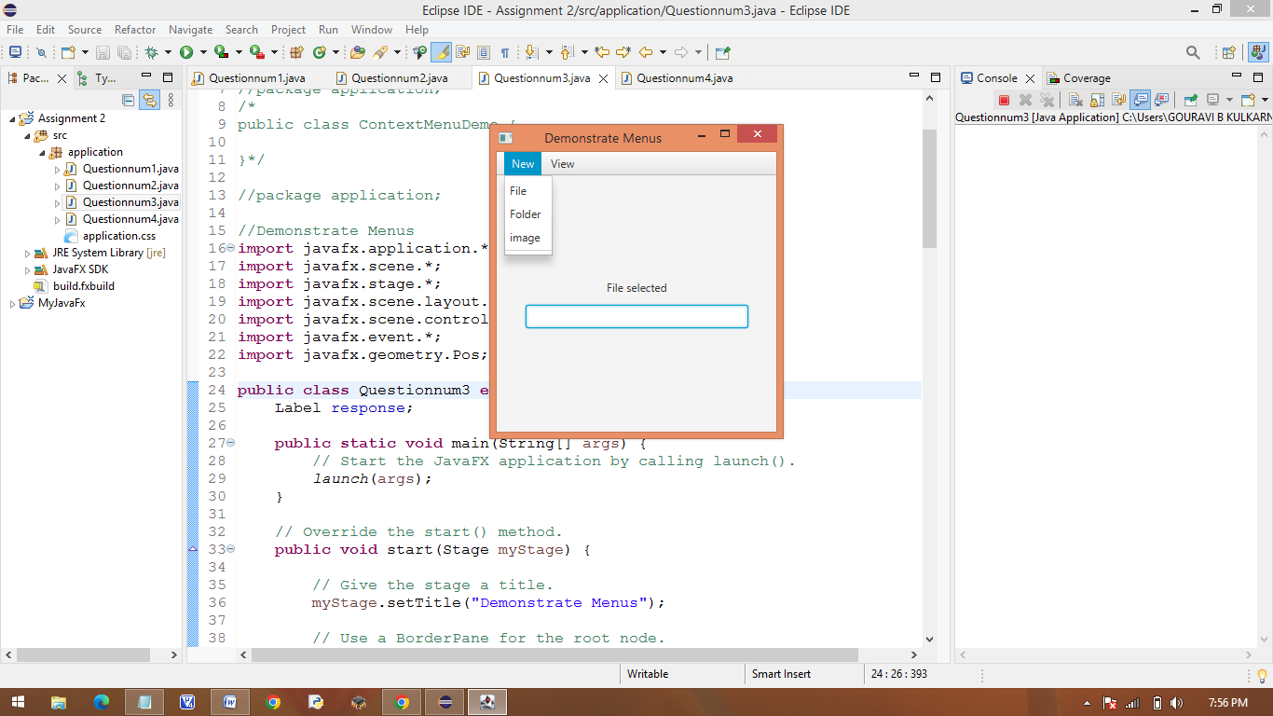

1. **Problem Definition:**

**Write a JavaFX program that produces the following output when executed and displays Dialog Box**

**(as shown in Figure.2) on click of Register button (as shown in Figure.1):**

**CODE PART :-**

**package** application;

**import** javafx.beans.*;

**import** javafx.collections.*;

**import** javafx.application.*;

**import** javafx.scene.*;

**import** javafx.stage.*;

**import** javafx.scene.layout.*;

**import** javafx.scene.control.*;

**import** javafx.event.*;

**import** javafx.geometry.*;

**import** java.io.IOException;

**public** **class** Questionnum4 **extends** Application {

**public** **static** **void** main(String[] args) {

// Start the JavaFX application by calling launch().

*launch*(args);

}

// Override the start() method.

**public** **void** start(Stage myStage) {

// Give the stage a title.

myStage.setTitle("Registration Form");

//Label for name

Label nameLabel=**new** Label("Name");

//Text Field for Name

TextField nameText=**new** TextField();

//Label for gender

Label genderLabel=**new** Label("gender");

//Toggle group of radio button

ToggleGroup groupGender=**new** ToggleGroup();

RadioButton maleRadio=**new** RadioButton("male");

maleRadio.setToggleGroup(groupGender);

RadioButton femaleRadio=**new** RadioButton("female");

femaleRadio.setToggleGroup(groupGender);

//Label for date of birth

Label dobLabel=**new** Label("Date of birth");

//date picker to choose date

DatePicker datePicker=**new** DatePicker();

//Label for Location

Label stateLabel=**new** Label("Select Your State");

//Choice box for location

ChoiceBox stateChoiceBox=**new** ChoiceBox();

stateChoiceBox.getItems().addAll(

"Andhra Pradesh","Arunachal Pradesh","Assam","Bihar","Chhattisgarh","Goa","Gujarat","Haryana"

,"Himachal Pradesh","Jammu and kashmir","Ladakh","Jharkhand","Karnataka","Kerala","Madhya Pradesh"

,"Maharashtra","Manipur","Meghalaya","Mizoram","Nagaland","Odisha","Punjab","Rajasthan","Sikkim"

,"Tamil Nadu","Telangana","Tripura","Uttarakhand","Uttar Pradesh","West Bengal"

);

//Label for technologies known

Label qualificationLabel=**new** Label("Select Your Qualifiaction");

//Check box for education

CheckBox UGCheckBox=**new** CheckBox("UG");

UGCheckBox.setIndeterminate(**false**);

CheckBox PGCheckBox=**new** CheckBox("PG");

PGCheckBox.setIndeterminate(**false**);

CheckBox PhDCheckBox=**new** CheckBox("PhD");

PhDCheckBox.setIndeterminate(**false**);

//Label for register

Button buttonRegister=**new** Button("Register");

Label valLabel=**new** Label();

buttonRegister.setOnAction(**new** EventHandler<ActionEvent>() {

**public** **void** handle(ActionEvent ae) {

**if**(nameText.getText().equals("")){

valLabel.setText("unsuccessfull");

}

**else** {

myStage.setTitle("Registartion Successfull");

FlowPane rootNode = **new** FlowPane(50, 50);

// Center the controls in the scene.

rootNode.setAlignment(Pos.***CENTER***);

Label status=**new** Label("Registration Status");

Separator separator = **new** Separator();

separator.setPrefWidth(100);

Label msg=**new** Label("Employee registration is Successful!!!");

Button btnVal=**new** Button("ok");

// Create a scene.

Scene myScene = **new** Scene(rootNode, 400, 300);

rootNode.getChildren().addAll(status,separator,msg,btnVal);

// Set the scene on the stage.

myStage.setScene(myScene);

}

}

});

//Crating a Grid Pane

GridPane gridPane=**new** GridPane();

//Setting size for pane

gridPane.setMinSize(500,300);

//Setting the padding

gridPane.setPadding(**new** Insets(10,10,10,10));

//Setting the vertical and horizontal gaps between the columns

gridPane.setVgap(5);

gridPane.setHgap(5);

//Setting the grid alignment

gridPane.setAlignment(Pos.***CENTER***);

//Arranging all the nodes in the grid

gridPane.add(nameLabel,0,0);

gridPane.add(nameText,1,0);

gridPane.add(genderLabel,0,2);

gridPane.add(maleRadio,1,2);

gridPane.add(femaleRadio,2,2);

gridPane.add(dobLabel,0,1);

gridPane.add(datePicker,1,1);

gridPane.add(qualificationLabel,0,3);

gridPane.add(UGCheckBox,1,3);

gridPane.add(PGCheckBox,2,3);

gridPane.add(PhDCheckBox,3,3);

gridPane.add(stateLabel,0,5);

gridPane.add(stateChoiceBox,1,5);

gridPane.add(buttonRegister,2,7);

gridPane.add(valLabel, 2, 8);

// Create a scene.

Scene myScene = **new** Scene(gridPane);

// Set the scene on the stage.

myStage.setScene(myScene);

// Show the stage and its scene.

myStage.show();

}

}

**OUTPUT:-**

